**Former Weld County educator to celebrate 100th birthday next week**

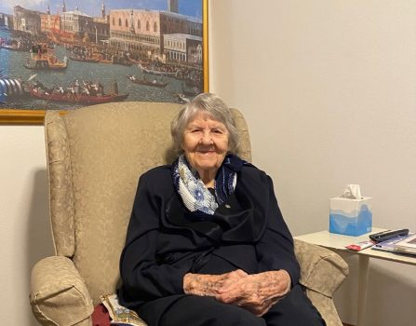

A Greeley woman is entering her 100th year of life “happy and content” at her senior living facility.

On Tuesday, Aug. 1, Dorothee Trowbridge will turn 100 surrounded by family and close friends, according to her daughter Edie.

Trowbridge was born Aug. 1, 1923, as the youngest child of five in Winnipeg, Canada. Her family relocated to Chicago, where her family grew with the addition of three younger sisters.

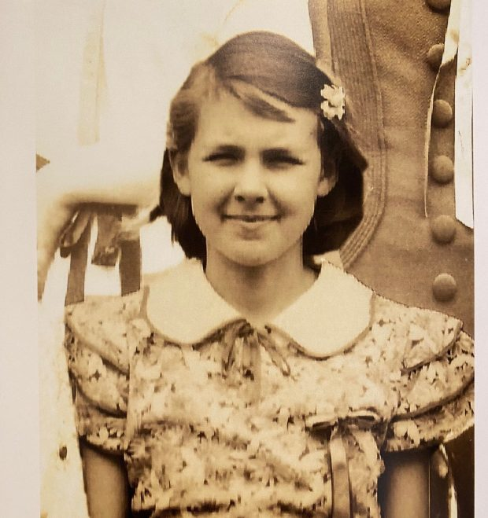

A picture after Dorothee Trowbridge graduated high school. She is turning 100 on Aug. 1. (Reporter/Morgan McKenzie)

In 1942, Trowbridge met her husband, Leslie. During World War II, Leslie was stationed in India and China as a weather officer for two years. Trowbridge worked jobs in Chicago and Florida as she waited for her fiance to return home. The couple married in 1946.

In 1962, Leslie took a job as a professor at the University of Northern Colorado, leading the Trowbridge family to move to Greeley. The two raised four children together.

Once their children were older, Trowbridge attended UNC to earn a master’s degree in education, according to Edie.

“She was the first in her family to go to college,” Edie said.

Trowbridge’s first college course was taught by her husband in the science department. Edie joked her father didn’t give Trowbridge any special treatment and graded her just like any of his other students.

After graduating, Trowbridge worked as a home economics teacher and substitute teacher in Weld County.

She and her husband often traveled for work, visiting places such as Taiwan, Korea, Egypt and Saudi Arabia. In addition to Weld County, Trowbridge also taught in New York City, Washington, D.C., and Taipei, Taiwan.

The couple was married for 66 years before Leslie died in 2012.

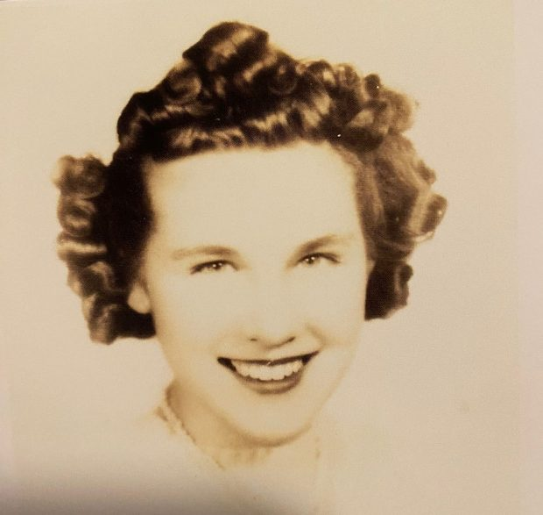

A picture of a young Dorothee Trowbridge, who is turning 100 on Aug. 1. (Reporter/Morgan McKenzie)

Trowbridge said she’s excited to turn 100 and go into the next chapter of her life.

Trowbridge spends her days at Brookdale Senior Living in Greeley with good people and good food. She loves that her home offers an in-facility saloon and a courtyard area, where she can enjoy the nice breeze and outdoors.

But her favorite part of Brookdale is interacting with other residents. Edie said everyone at the facility likes Trowbridge, who is very congenial and always smiling.

Trowbridge’s family and close friends will gather at a park to celebrate her centennial. Colorado nonprofit Whispering Hearts Therapy, which provides therapeutic services through animal-assisted visits, will bring two mini horses to the festivity.

Cycling Without Age will also take Trowbridge on a bike ride in a trishaw for the special occasion.

“I’m glad I am here among friends and family,” Trowbridge said. “I’m especially glad to have my daughter here.”